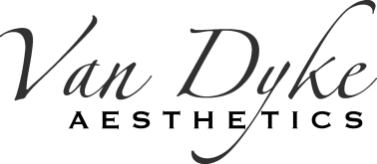
5206 N Scottsdale Rd
Paradise Valley, AZ
85253
480.948.5045

PATIENT INFORMATION
Patient Name: |  |  |  |  |  | Date of Birth:
Address:

City: |  |  |  | State: |  |  |  | Zip Code:
Home Phone: | Mobile Phone: |  |  |  |  |  | Work Phone:
How did you hear about us?

Current Occupation: |  |  |  |  | Employer:
Emergency Contact:

Name: Phone: Relationship:

Newsletter and Appointment confirmation
Would you like to receive Van Dyke Aesthetics monthly newsletter?

Yes No

Please list your email to join:_____________________________________

Van Dyke Aesthetics is now offering quick and easy text message appointment reminders!
How do you prefer to receive your appointment reminders?

Text Automated Voice Call don’t want reminders I

***To receive appointment reminders directly to your cell phone, please text vandykelaser to 622622. A confirmation text will be sent back immediately to your cell phone, to complete the opt-in.

Financial responsibility
Payment in full for all services and products is made at time of service. Treatment at Van Dyke Aesthetics is cosmetic and therefore not covered by insurance or Medicare. The patient is financially responsible for all services and products. Please notify us if you will be late or unable to make your scheduled appointment. Failure to cancel a scheduled appointment within 24hours will result in an office visit charge.

Van Dyke Aesthetics is required by applicable federal and state law to maintain the privacy of your health information. It is our intent to comply with all rules and regulation that apply to our practice and maintain the highest standard in protecting the privacy of our patients. For more information about our privacy practices, or to receive a copy of our Notice or Privacy Practices, please ask to speak with our Office Manager.

_____________________________________________________________ ____________________________
Signature Date

